English Learning Area

Primary Transition - Students
This competition provides a great opportunity to celebrate the wonderful worlds created in children’s literature. It will encourage children to share their reading experiences and think about what makes a good story setting, using their imaginations to explore a story.
Coombeshead Academy
Inspiring Excellence
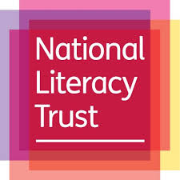
Coombeshead Academy and
the National Literacy Trust

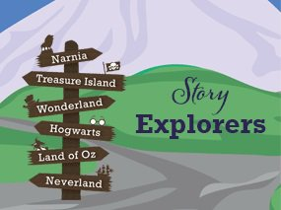

Reading is really important to us at Coombeshead Academy. As a class you will read a wide selection of books, both in tutor time and through our English Canon such as Goldfish Boy and The Girl of Ink and Stars. You’ll get to enjoy a range of classic texts, modern novels, fantasy, horror and stories from other cultures around the world. In addition, each day during Drop & Read you’ll get to choose your own novel to read; you then get to quiz on your books and earn points and prizes!
We also have exciting activities throughout the year where you’ll get the chance to participate in fun events like World Book Day and even to meet famous authors. We even have clubs like a reading club, debate club and a school magazine!
Over the Summer we would like you to get inspired by your favourite book and the imaginary world you entered. Your work will be entered in a competition and then displayed in our library.
Have you ever wanted to explore a story? Perhaps you would like to visit the Chocolate Factory with Charlie, ride a polar bear in the frozen North with Lyra or travel to Middle-earth’s Lonely Mountain with Bilbo Baggins?

Whatever your favourite, we’re challenging you to write a short visitor’s guide to or create a map of your favourite story setting in children’s literature. You will investigate what makes a good story location, and will apply your imagination and creativity to writing (and drawing!) with real purpose.

Story Explorer Visitor’s Guide
Some rules:
• must be about a setting from a published children’s book
• should be made by hand or on the computer
• should be created on A4 paper
• can be either in the style of a poster, a folded leaflet or even a booklet
• should have no more than 400 words
• may include images and a map.

Explore the story
Story worlds are full of exciting places to go, things to do and people (or maybe magical creatures!) to see. Using the template provided, list what you know about your chosen story setting. What are the things that will make the setting exciting to explore? You could think about:

• Location
What kind of atmosphere does the place have? Scary, funny, exciting? Is the setting a ‘real’ place or fantasy, or a combination of both? Or is the setting historical?

• Climate
Is it a hot or cold place? Will they need to wear special clothes? They might need a costume! What will the weather be like? Maybe the story is set in space!

• Transport
How will visitors get there? If it’s a different place in time, they might need a time machine. If the story is set in space, they might need a rocket. Or maybe they’ll travel by horse and cart! Is there a special way to explore the world they’re visiting? Maybe they’ll have to travel by umbrella!

• Attractions
Are there different attractions that could be visited? For example, if you went to Hogwarts you might like to visit Hogsmeade and the Shrieking Shack. Or if you went to Dream Country you might want to see the dream jars. Is there anywhere that should be avoided if it’s dangerous?

• Things to do
What can they do while they’re there? Ride a dragon with Horrendous Hiccup or go on a motorbike with Gangsta Granny? Or maybe race through the jungle with Mowgli and Baloo the Bear?

• Food
What food can they expect to eat when they get there? Are there places to eat? Will they be able to eat the food or is it dangerous? Maybe they could try Willy Wonka’s everlasting gobstoppers or have a picnic with The Famous Five?

• People
Who might they see when they are there? Maybe they’ll meet some hobbits, or Tom Gates or Mabel Jones! This is a great opportunity to talk about the characters in the book and think about what kinds of people or creatures live in the story world they’re focusing on.
Map the story

Every story deserves a good map! Maps help us explore and when it comes to a good story we don’t want to miss anything. Think about the maps you remember from children’s books - The Hobbit, Lord of the Rings, Narnia, The Marauder’s Map in Harry Potter or The Isle of Berk in How to Train Your Dragon. Maps can be really creative and show more than just locations and geographical features - they can bring all the elements of the story to life and show us what it might be like to explore them! Whether you are going to create just a map or a visitor’s guide with a map, think about what they can include. The map could be of a whole world or just a small cityscape, depending on the setting.
If you want to have a practice, try creating a story setting map of a well-known fairy tale such as Jack and the Beanstalk or Little Red Riding Hood and think about what key information you would include in a visitor’s guide – beware of the wolf!

Some Rules:
• must be about a setting in a published children’s book
• should be made by hand or on the computer
• should be created on A4 paper
• can include words/labels
• can be made using the template provided
Please note entries must not be reproductions of maps from children’s books – they must be original designs based on a children’s book.

BONUS TASKS
BOOK MARK CHALLENGE
Cut out the book marks so you don’t lose your page.
Record the different ways you have enjoyed reading books.
Draw a picture on the back linked to your book or list:
x3 key characters
x3 locations from the book
x3 emotion you felt!
Coombeshead Academy
Reading Challenge
Name ………………..

Read a book that inspired a film or musical or play.
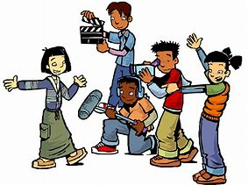

Read in an unexpected place –bring in a photo or drawing
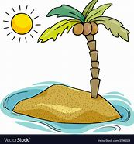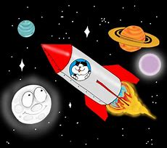

Read in the park or in a treehouse
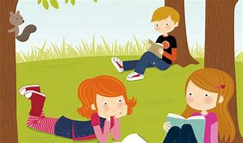
Read aloud to a furry friend – alive or not!
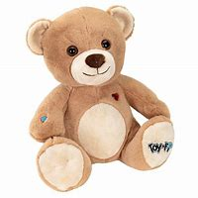

Read a book from a library.
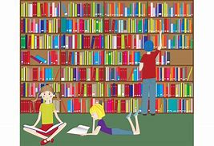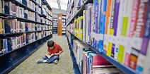

Coombeshead Academy
Reading Challenge
Name ………………..
R

Read in a homemade den - bring in a photo or drawing!
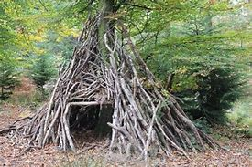

Read a non-fiction book.
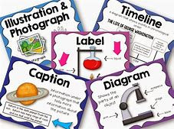

Read a book recommended by a friend or family member. 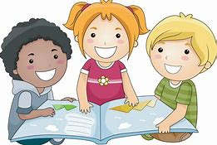

Read in the bath - not the shower!! 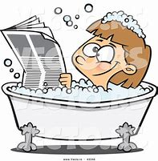

Read under a blanket or duvet with a torch.
