Year 6 Induction – Plants
Activity 1

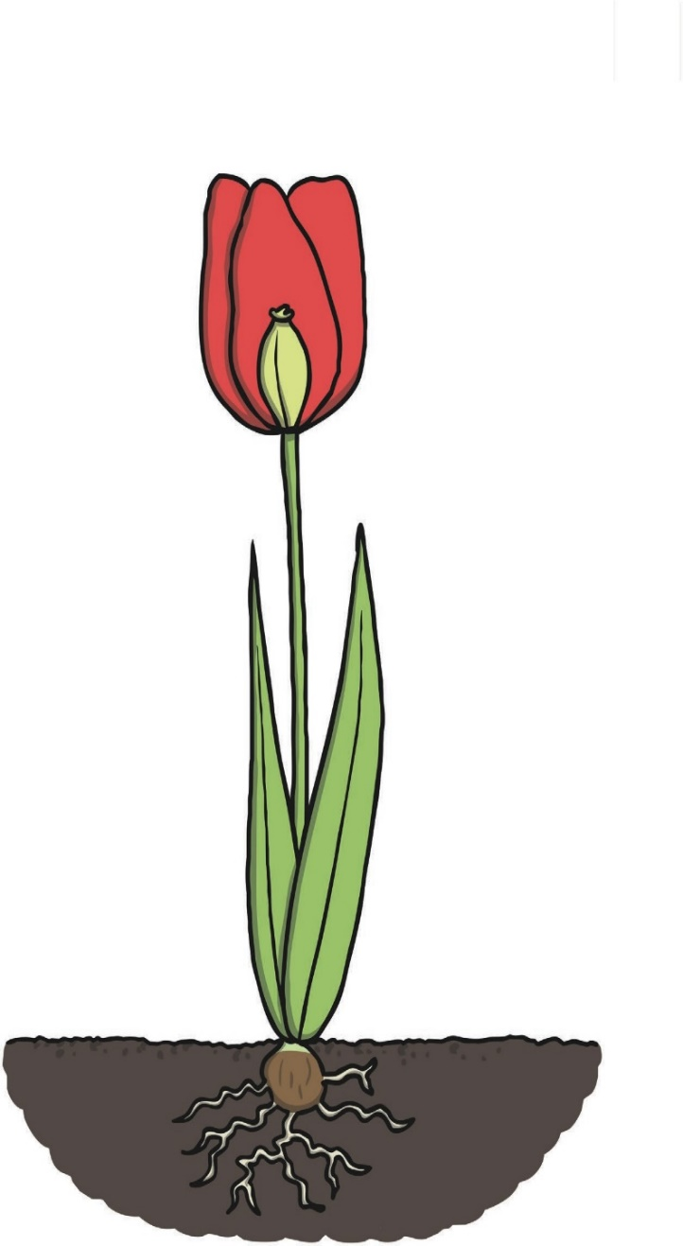
- Label the organs of this plant.

- Research and find out the function of each of these organs.
https://www.bbc.co.uk/bitesize/topics/znyycdm/articles/zjchsrd

3. Complete a little research and label this diagram of a flower.
https://www.bbc.co.uk/bitesize/guides/zs7thyc/revision/1
The second diagram will help, but look carefully to make sure you are labelling the correct parts.
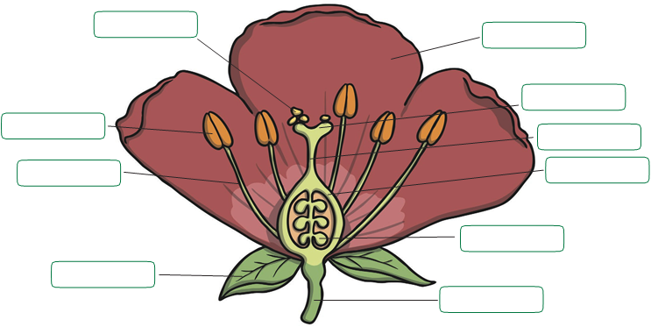
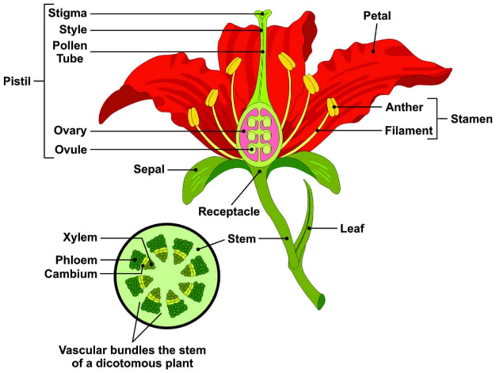

- Complete some research and find out the function of each of these parts. https://www.bbc.co.uk/bitesize/guides/zs7thyc/revision/1
Try and present this information in a table, as shown:

Name of part | Function
Activity 2
- For this activity you will be applying your knowledge of the parts of a flower to a dissection
First you need to try and collect a few different flowers. These can be wild flowers you find growing in the hedgerow or in the park, flowers from a bunch of flowers you may have in a vase at home or flowers you have growing in the back garden. Careful when you are collecting them.

You should aim to collect at least 5 different types of flowers. Some examples of flowers that work really well are shown below:
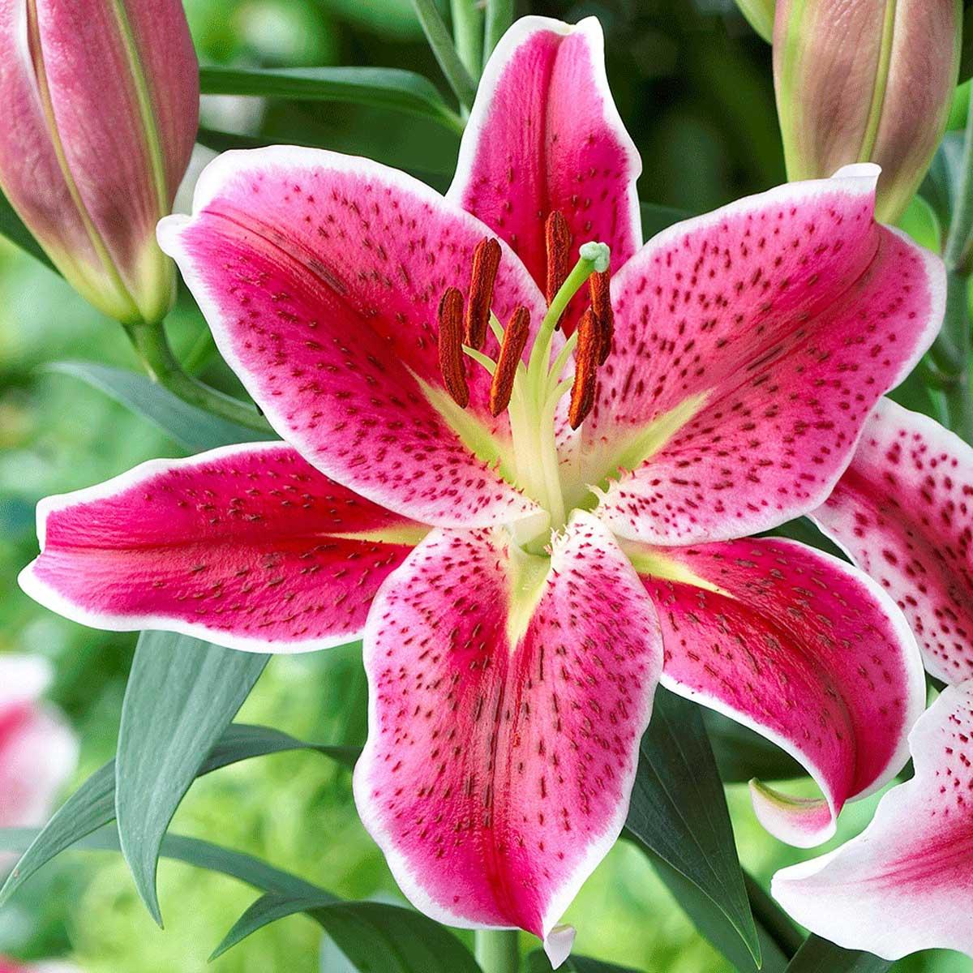 Lillies 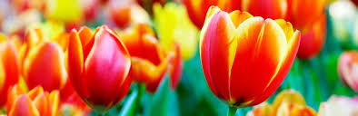 Tulips 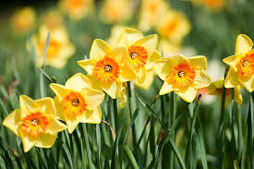 Daffodils

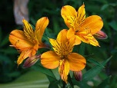 Alstroemarias 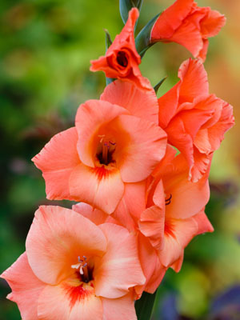 gladiolus 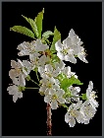 wild cherry blossoms

- You are going to dissect each of the flowers that you have collected and present the flower parts to demonstrate understanding. Each dissection should include labels stating what the part is called and its function. You should include a title for each of the dissections, this title if possible, should be the name of the flower.
See example below:

